Envoy handbook

The aim of this document is to show you how to download and view the audit and patient experience data on Envoy.
Please email elft.qa@nhs.net if you have any questions, suggestions for improvement or need additional help.
Contents
Envoy link 2
Patient Experience 3
Download raw data 3
View charts 4
Download reports 5
FFT Service Report (Summary) 6
Local Surveys – Response Report 7
Qualitative feedback analysis and you said we did posters 8
Audit 10
Download raw data 10

Envoy link

https://v3.nhssms.com/Envoy/Account/Login?ReturnUrl=%2F​

Patient Experience

Download raw data
In order to download raw data, please follow the following steps:
- Click on “Dashboard” which is under “Patient Experiences – Local Surveys” (as shown in the image below)
- Complete the dashboard:
  - “Department” - select your directorate
  - “Date Mode” – select discharge date
  - “Date From” and “Date to”
  - “Survey type” – select Patient FFT
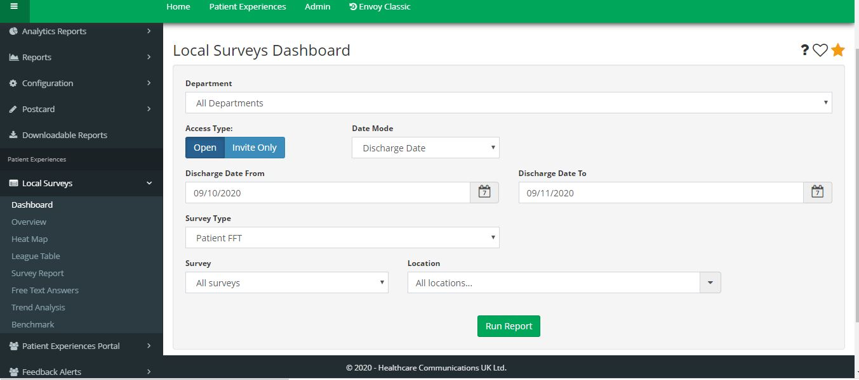
  - “Survey” – select which survey you wish to see. Please note: some surveys have “OLD” in their titles. These are surveys that have been archived.
  - “Location” – select your team
- Click on “Run Report”
The image below shows what your dashboard will look like when you follow the steps above.

View charts
In order to see the patient experience data presented in charts, please follow these steps.
- 1. Click on “Overview” which is under “Patient Experiences – Local Surveys” (as shown in the image below)
- Complete the dashboard:
  - “Department” - select your directorate
  - “Date Mode” – select discharge date
  - “Date From” and “Date to”
  - “Survey type” – select Patient FFT
  - “Survey” – select which survey you wish to see. Please note: some surveys have “OLD” in their titles. These are surveys that have been archived.
  - “Location” – select your team
  - “Chart type” – select what chart type you prefer
- Click on “Run Report”

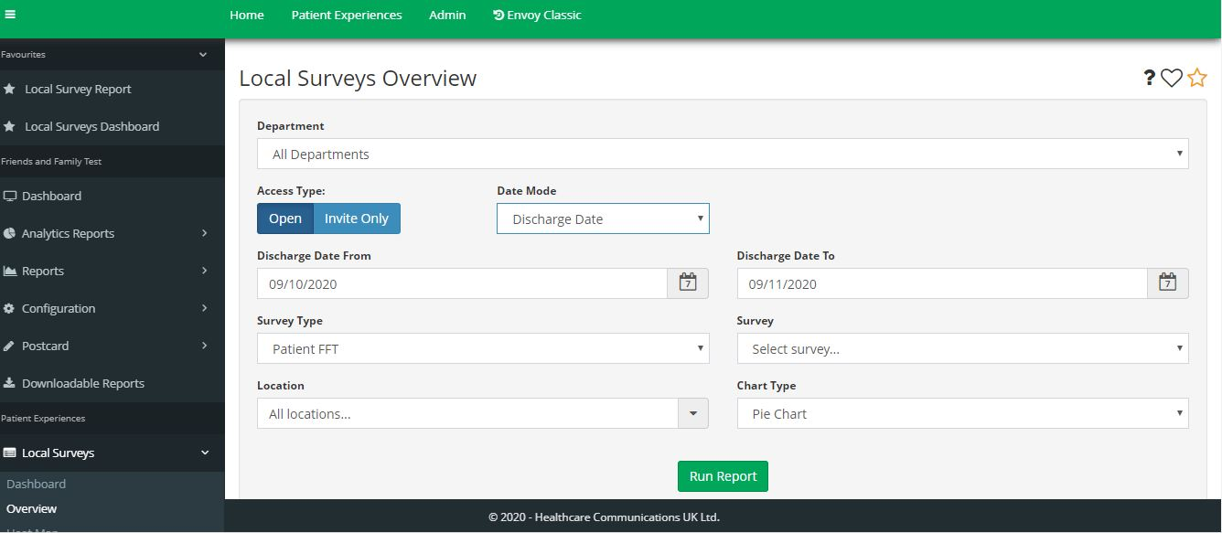
The image below shows what your dashboard will look like when you follow the steps above.

Download reports
In order to download reports with charts, please follow the next steps.
- Click on “Downloadable reports” under Friends and Family Test and then click on “Run” (as can be seen in an image below)
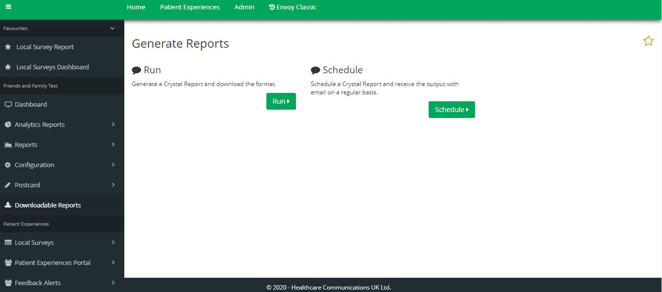

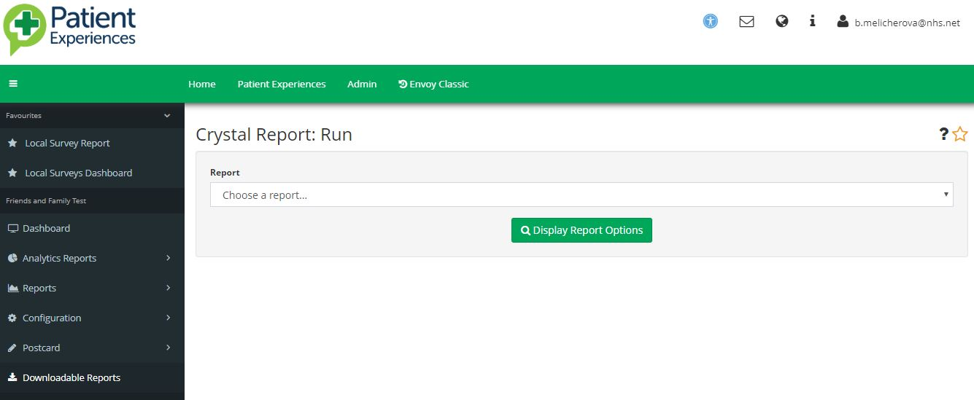
When you click on “run”, you will see the following dashboard:

- Choose one of the following two reports:
  - FFT Service Report (Summary)
    - This report will include a one-page summary of answers submitted to “Overall, how was your experience of our service?”
  - Local Surveys – Response Report
    - This report will include aggregated data to all the questions asked in the PREM survey

FFT Service Report (Summary)
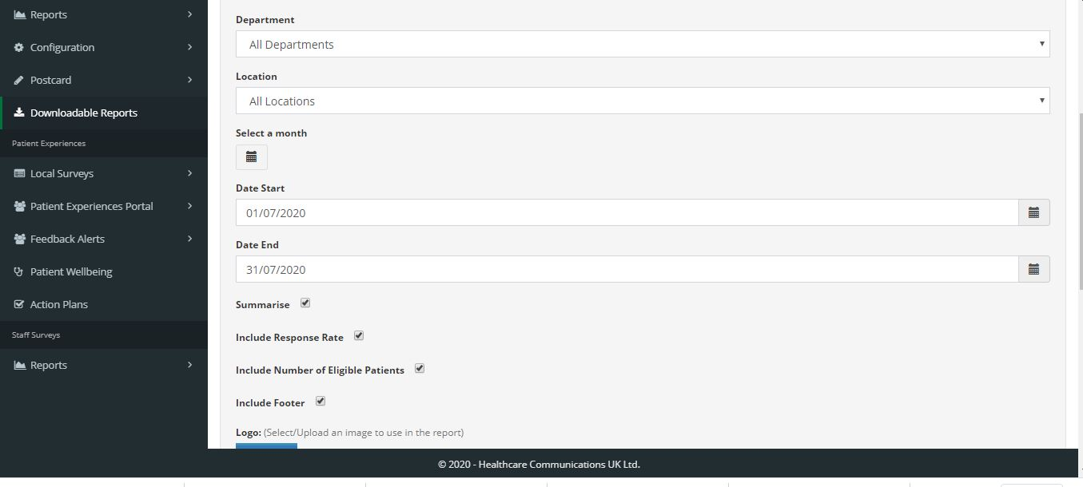
If you select FFT Service Report (Summary), you will see the following dashboard.

In order to generate the report, you just need to complete the dashboard:
- “Department” - select your directorate
- “Date Stat” and “Date End” – select time frame needed
- “Location” - choose your team
- The following options are dependent on your preference:
  - Summarise
  - Include Response Rate
  - Include Number of Eligible Patients
  - Include Footer
- Report Format – select which format you prefer, the majority of the services use PDF
- Click on “Run Report”

Local Surveys – Response Report
If you select FFT Service Report (Summary), you will see the following dashboard.
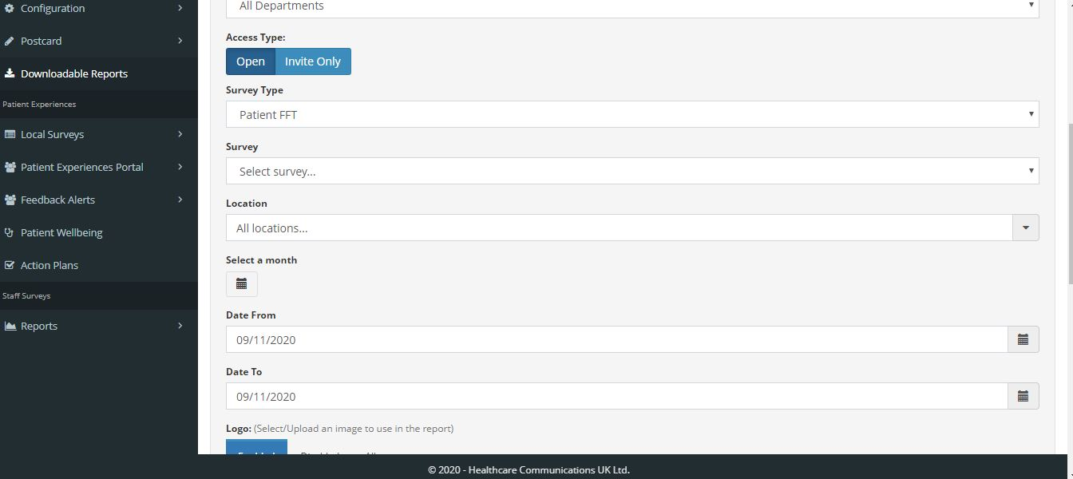
In order to generate the report, you just need to complete the dashboard:
- “Department” - select your directorate
- “Survey type” – select Patient FFT
- “Survey” – select Directorate
- “Location” - choose your team
- “Date Stat” and “Date End” – select time frame needed
- “Chart responses breakdown” – select which option you prefer
- Report Format – select which format you prefer, the majority of the services use PDF
- Click on “Run Report”

Qualitative feedback analysis and you said we did posters
If you would like to better understand the qualitative feedback your service users have provided, please follow the next steps:
- Click “Dashboard” under Friends and Family test (as can bee seen in the image below)
- Complete the dashboard
  - “Department” - select your directorate
  - “Location” - choose your team
  - “Date From” and “Date to” – select time frame
- Click on “search”
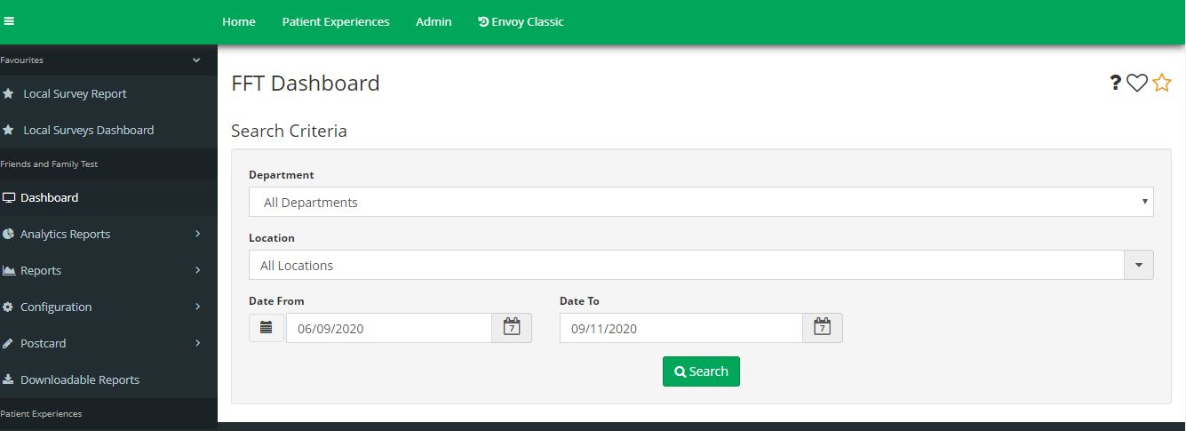

You will see a new dashboard underneath, that will look similarly to the image below.

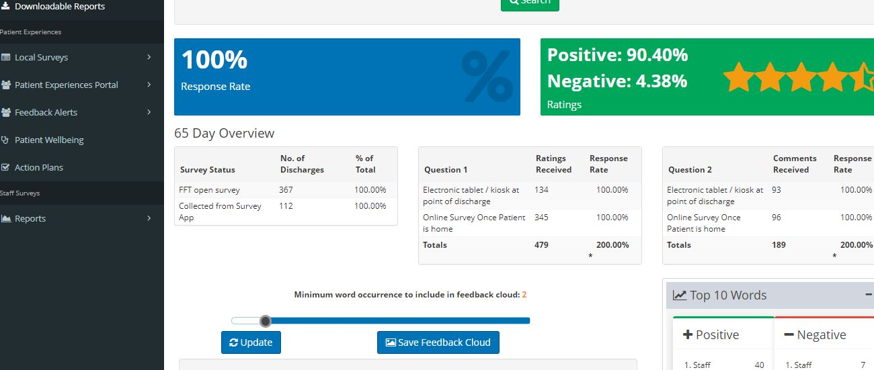
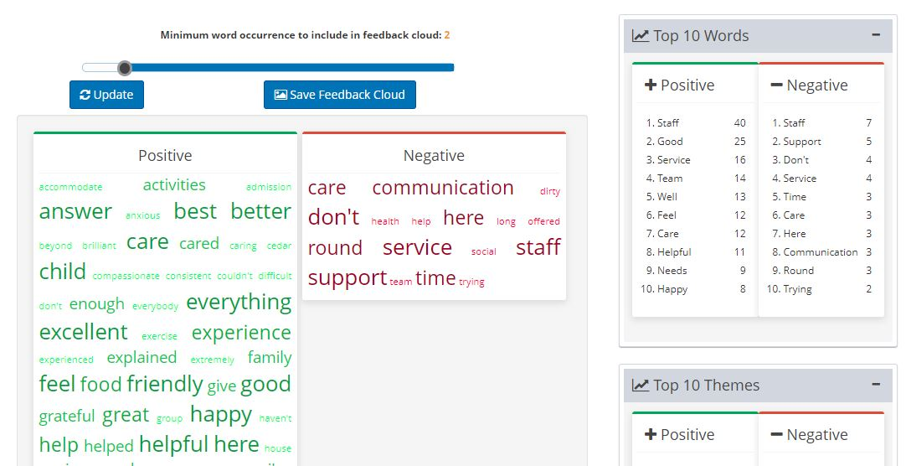

The dashboard shows a positive and a negative word cloud, top 10 words or top 10 themes. If you click on any of the words, you can see the full sentence in which the word was used.
In addition, if you click on the green box on the word “positive” or “negative”, you will be able to see more details regarding the comments in a new window (it will look similarly to the image provided below).

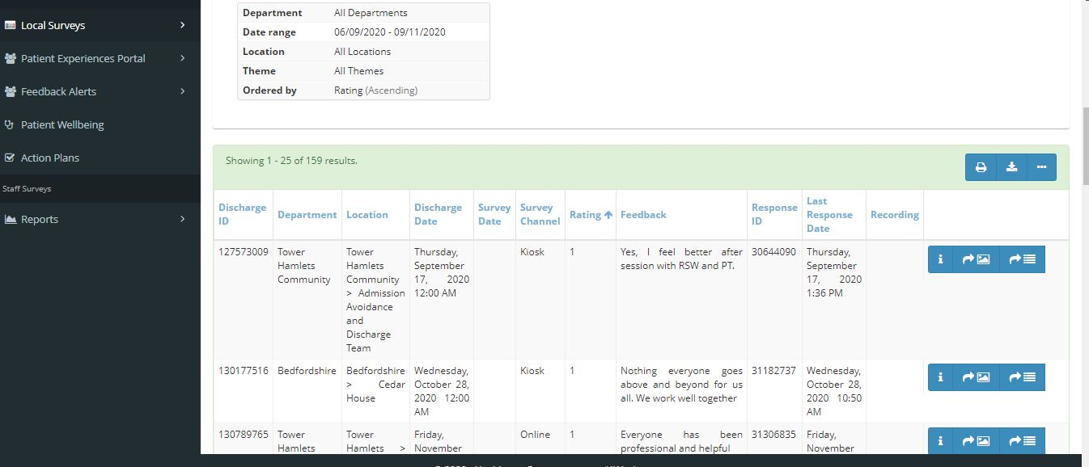
Here you can create “you said we did posters”.
- Choose a comment you want included in the poster
- Click on the arrow pointing to the image (as shown in an image below)
- Once you have selected all the comments, click on the arrow pointing down (next to the download button)

Audit

Download raw data
In order to download raw audit data, please follow the following steps:
- Click on “Dashboard” which is under “Patient Experiences – Local Surveys” (as shown in the image below)
- Complete the dashboard:
  - “Department” - select Audit and CQC Surveys
  - “Date From” and “Date to” – select your preferred range
  - “Survey type” – select Survey
  - “Survey” – select which audit you wish to see. Please note: some surveys have “OLD” in their titles. These are surveys that have been archived.
  - “Location” – select your team
- Click on “Run Report”

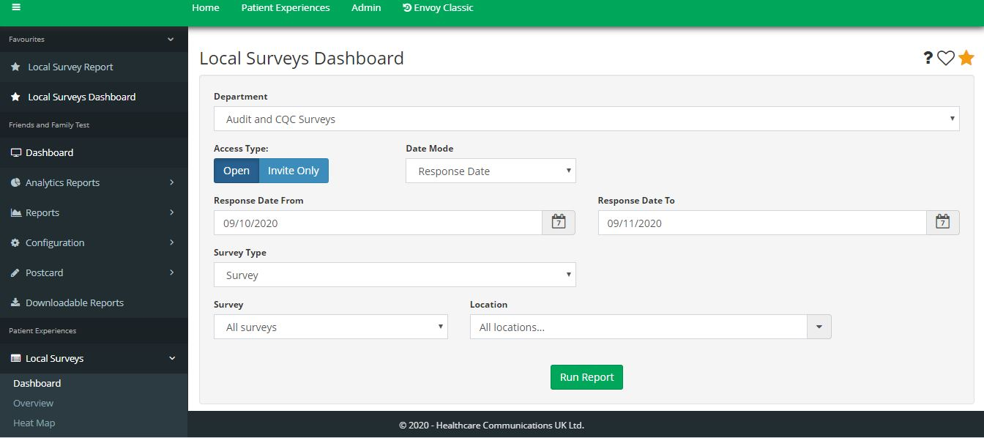
The image below shows what your dashboard will look like when you follow the steps above.

